Comparing Constitutions: U.S. "Bill of Rights" vs. Iran "The Rights of the People" Grades 7 – High School

Objectives: Students will be able to analyze and interpret common ideas on government and human rights that are present in different founding documents

Standards:

USG.2.3 Analyze and interpret central ideas on government, individual rights, and the common good in founding documents of the United States.

USG.3.1 Analyze the United States Constitution and explain characteristics of government in the United States,which define it as a federal, presidential, constitutional and representative democracy.

USG.4.1 Compare and contrast governments throughout the world with the United States government in terms of source of the government’s power.

USG.4.2 Describe how different governments interact in world affairs. (Individuals, Society and Culture)

USG.4.8 Identify and explain world issues, including political, cultural, demographic, economic and environmental challenges that affect the United States foreign policy in specific regions of the world.
7.1.13 Identify and explain the significance of historical events in the Middle East since the end of World War II.

Approximate Length: 2 days (45 minutes each day)

Materials Needed:

Copy of U.S. Bill of Rights
Copy of Iranian Constitution's Introduction and Chapter 3
Venn Diagram

About the Lesson:

In this lesson, students look at the Iranian Constitution's "The Rights of the People" and compare/contrast with the U.S. Constitution "Bill of Rights." This lesson is best used as part of an overall unit about the U.S. Constitution or as a supplemental lesson. It is suggested that students have been previously introduced to the history of the U.S. Constitution and its Bill of Rights.

Procedures:

Day 1:

Put students into small groups or pairs. Assign them each a part of the Iranian Constitution's Preamble. Have students read their specific section and take notes on the reading. Near the end of class, have each pair/group present their information as summary to the class (They should present in the same order that the Iranian Constitution Preamble is organized). Here are the following sections (in order as they appear):

Preamble
The Dawn of the Movement
Islamic Government
The Wrath of the People
The Price the Nation Paid
The Form of Government in Islam
The Wilayah of the Just Faqih (may be combined with another smaller section)
The Economy is a Means Not an End
Woman in the Constitution
An Ideological Army
The Judiciary in the Constitution
Executive Power
Mass-Communication Media
Representatives

Day 2:

1. Pair/Group work: Cut-out and pass around the U.S. Bill of Rights quotes (Quotes PDF). Give students 3 – 5 minutes to discuss their quote and whether they agree or disagree. After the discussion in pairs, have students present their quotes to class and share their opinions.
2. Put students in the same pairs/groups from the previous day. Tell them that today they will be comparing the U.S. Bill of Rights and the Iranian Constitution's "The Rights of the People" (Chapter 3, Articles 19 – 42). Hand students a copy of each. Working in their pairs/groups, students are to complete a Venn Diagram comparing the two documents.
3. When students are finished, have each pair/group share one similarity or difference that they found.

Resources:

U.S. Constitution Bill of Rights:

http://constitutionus.com/?t=Bill%20of%20Rights

Iranian Constitution "Chapter III: Rights of the People":

http://www.iranchamber.com/government/laws/constitution_ch03.php

Iranian Constitution

https://www.constituteproject.org/constitution/Iran_1989.pdf?lang=en

Constitution Venn Diagram

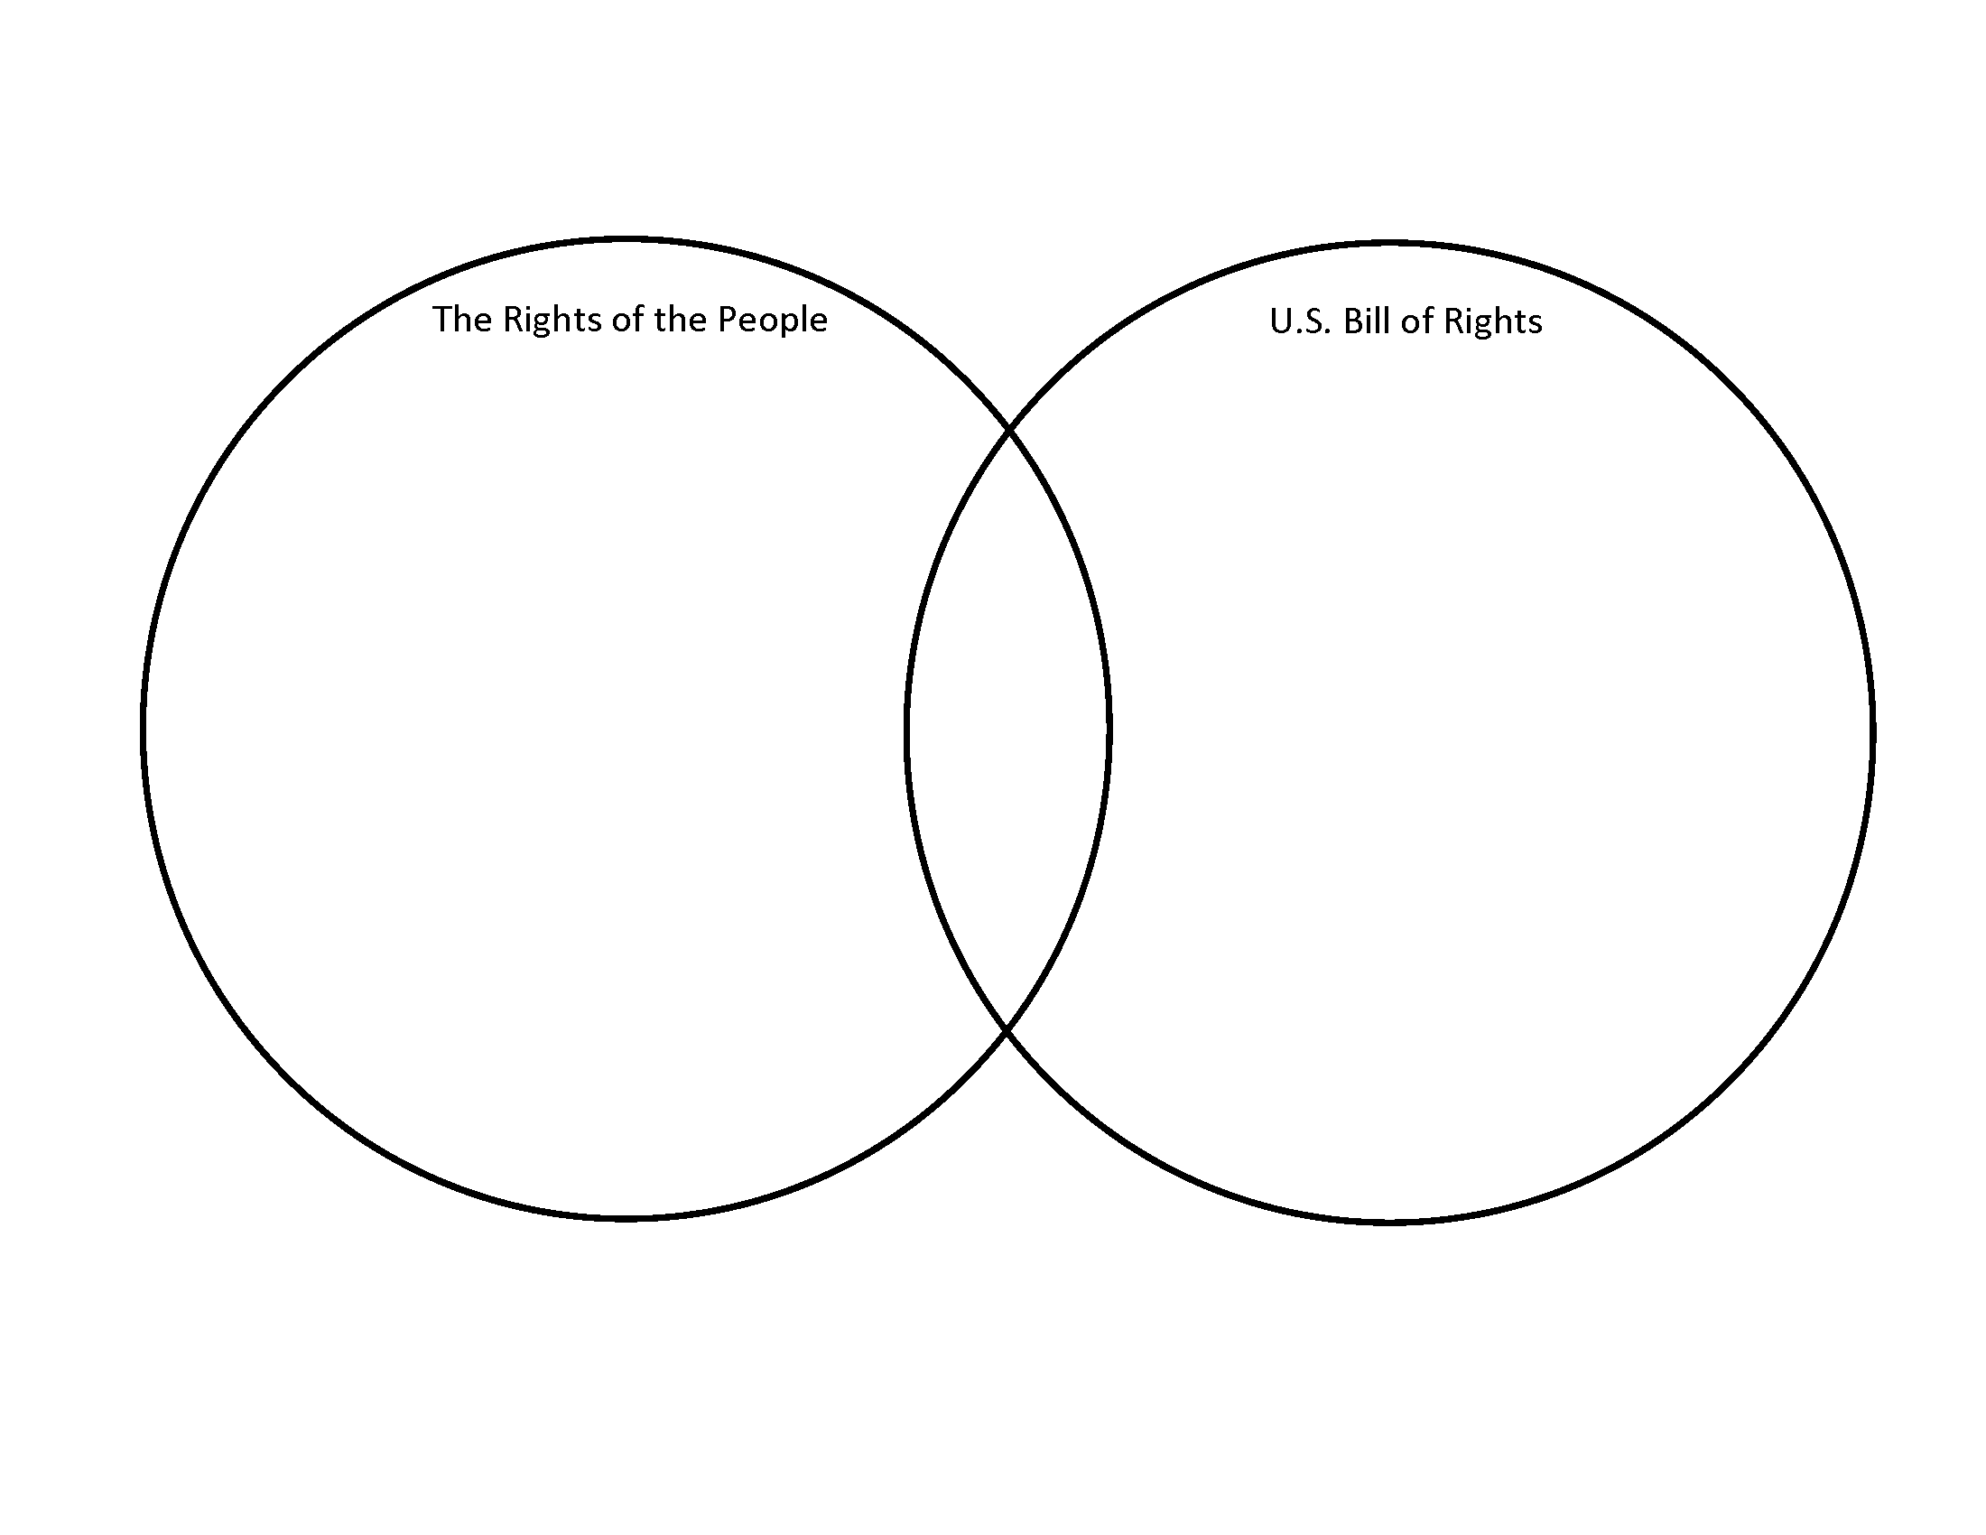

Constitutional Quotes

A Bill of Rights is what the people are entitled to against every government, and what no just government should refuse, or rest on inference.  Thomas Jefferson | The Bill of Rights isn't some legalistic fine print. It was written to make our lives freer, more prosperous, and happier. By forsaking it, America has become no better than any other country in the world.  Harry Browne
The real question is, when will we draft an artificial intelligence bill of rights? What will that consist of? And who will get to decide that?  Gray Scott | If the citizens of the United States are to turn away from the Communist Manifesto and preserve the purpose of the Declaration of Independence, the U.S. Constitution, and our Bill of Rights, we must first thoroughly reexamine and learn about each of them, and uphold America's founding documents by testing every political action in light of them.  Chuck Norris
If the citizens of the United States are to turn away from the Communist Manifesto and preserve the purpose of the Declaration of Independence, the U.S. Constitution, and our Bill of Rights, we must first thoroughly reexamine and learn about each of them, and uphold America's founding documents by testing every political action in light of them.  Chuck Norris | People in this country need to understand when you go to any airport in the United States, you are not protected by the Constitution or the Bill of Rights. They can do anything they want to you, and there is no where you can go to seek redress.  Jesse Ventura

People in this country need to understand when you go to any airport in the United States, you are not protected by the Constitution or the Bill of Rights. They can do anything they want to you, and there is no where you can go to seek redress.  Jesse Ventura | I think most people have a general idea of the Constitution, and somewhat of the Bill of Rights.  Virgil Goode
The Second Amendment is an integral part of the Bill of Rights. Ted Cruz | The Constitution remains brilliant in its overall design and sound with respect to the Bill of Rights and the separation of powers. But there are numerous archaic provisions that inhibit constructive change and adaptation. These constitutional bits affect the daily life of the republic and every citizen in it.  Larry J. Sabato
This has been the new normal since September 11. Everyone knows, but nobody says, that if something happens again, the elite consensus in this country, and the overwhelming consensus of the citizenry, will be to pitch the Bill of Rights out the window and start rounding folks up.  Charlie Pierce | The Constitution remains brilliant in its overall design and sound with respect to the Bill of Rights and the separation of powers. But there are numerous archaic provisions that inhibit constructive change and adaptation. These constitutional bits affect the daily life of the republic and every citizen in it.  Larry J. Sabato

